Run the Application

|  |  |
| --- | --- |
| **Date** | 11-11-2022 |
| **Team ID** | PNT2022TMID30346 |
| **Project Name** | AI-based localization and classification of skin diseases with erythema |

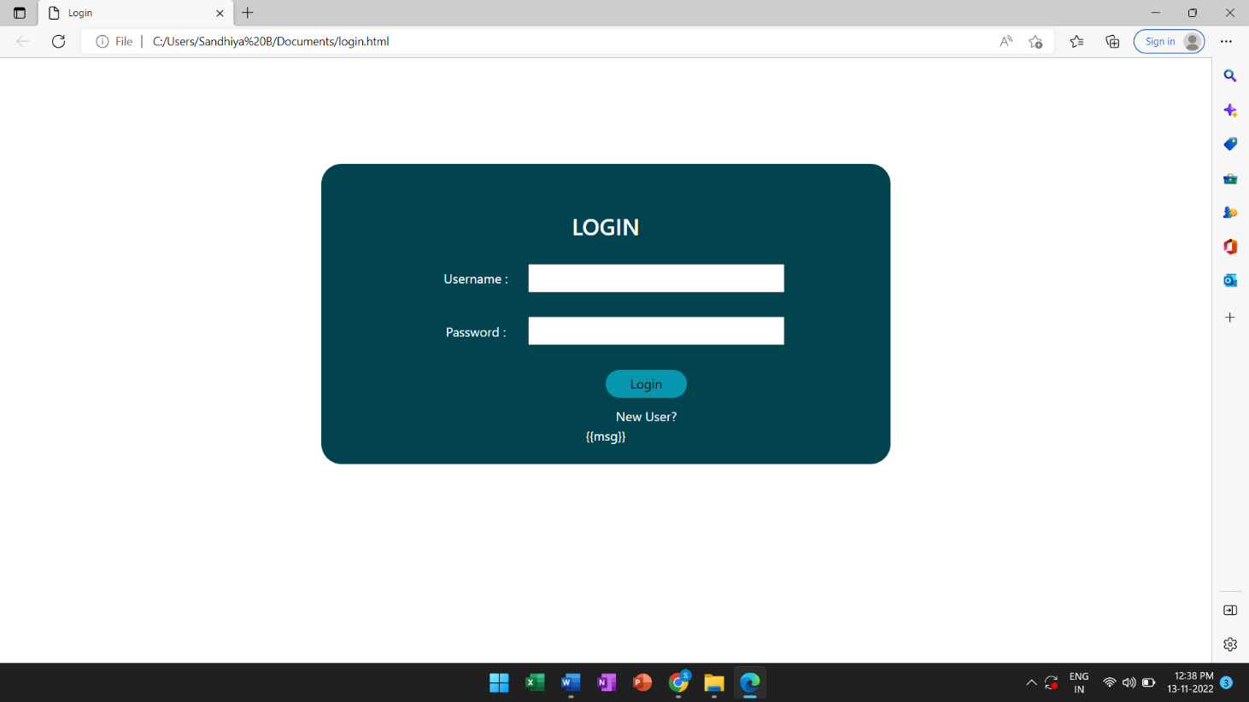**BUILD HTML CODE:**

